**Based On SAT Practice Test #7, First Passage**

**Vocabulary**

1. **Worship - to have or show a strong feeling of respect and admiration for God or a god.**

Sentence example - On the island the people worshipped different gods.

1. **Compact - consisting of parts that are positioned together closely or in a tidy way, using very little space.**

Sentence example - What a compact office! How did you fit so much into so little space?

1. **Monotony - a situation in which something stays the same and is therefore boring.**

Sentence example - The monotony of motorway driving can cause accidents.

1. **Loom - a piece of equipment for weaving (= making thread into cloth).**

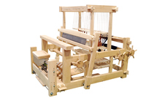

1. **Forth - (from a place) out or away, or (from a point in time) forward.**

Sentence example - From that day forth he never drank again.

1. **Crawl - to move along on hands and knees or with your body stretched out along a surface.**

Sentence example - The injured soldier crawled to safety.

1. **Lasting - continuing to exist for a long time or forever.**

Sentence example - Did any of your teachers make a lasting impression on you?

1. **Meadow - a field with grass and often wild flowers in it.**

Sentence example - There was a path through the meadow to the village.

1. **Hedgerows - a line of different types of bushes and small trees growing very close together, especially between fields or along the sides of roads in the countryside.**

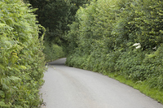

1. **Plucks - to pull something, especially with a sudden movement, in order to remove it.**

Sentence example - Caged birds sometimes pluck out their breast feathers.

1. **Stupefy - to make someone unable to think clearly, usually because they are extremely tired or have taken drugs.**

Sentence example - He was stupefied with alcohol.

1. **Imperative - extremely important or urgent.**

Sentence example - The president said it was imperative that the release of all hostages be secured.

1. **Mischief - behaviour, especially a child's, that is slightly bad but is not intended to cause serious harm or damage.**

Sentence example - She's a lively little girl, full of mischief.